**DAILY ONLINE ACTIVITIES SUMMARY**

|  |  |  |  |  |  |  |  |  |
| --- | --- | --- | --- | --- | --- | --- | --- | --- |
| **Date:** | **07-06-2020** | | | | | **Name:** | **SHAIFA SHALA** | |
| **Sem & Sec** | **6 B** | | | | | **USN:** | **4AL17CS084** | |
| **Online Test Summary** | | | | | | | | |
| **Subject** | | **SYSTEM SOFTWARE AND COMPILER DESIGN** | | | | | | |
| **Max. Marks** | | **30** | | **Score** | | | **24** | |
| **Certification Course Summary** | | | | | | | | |
| **Course** | **INTRODUCTION TO CLOUD** | | | | | | | |
| **Certificate Provider** | | | **IBM** | | **Duration** | | | **5 days** |
| **Coding Challenges** | | | | | | | | |
| **Problem Statement: 1 Java and 1 Python program** | | | | | | | | |
| **Status: Executed** | | | | | | | | |
| **Uploaded the report in Github** | | | | | **Yes** | | | |
| **If yes Repository name** | | | | | **https://github.com/shaifashala/DailyReport.git** | | | |
| **Uploaded the report in slack** | | | | | **Yes** | | | |

Online Test Details: (Attach the snapshot and briefly write the report for the same)

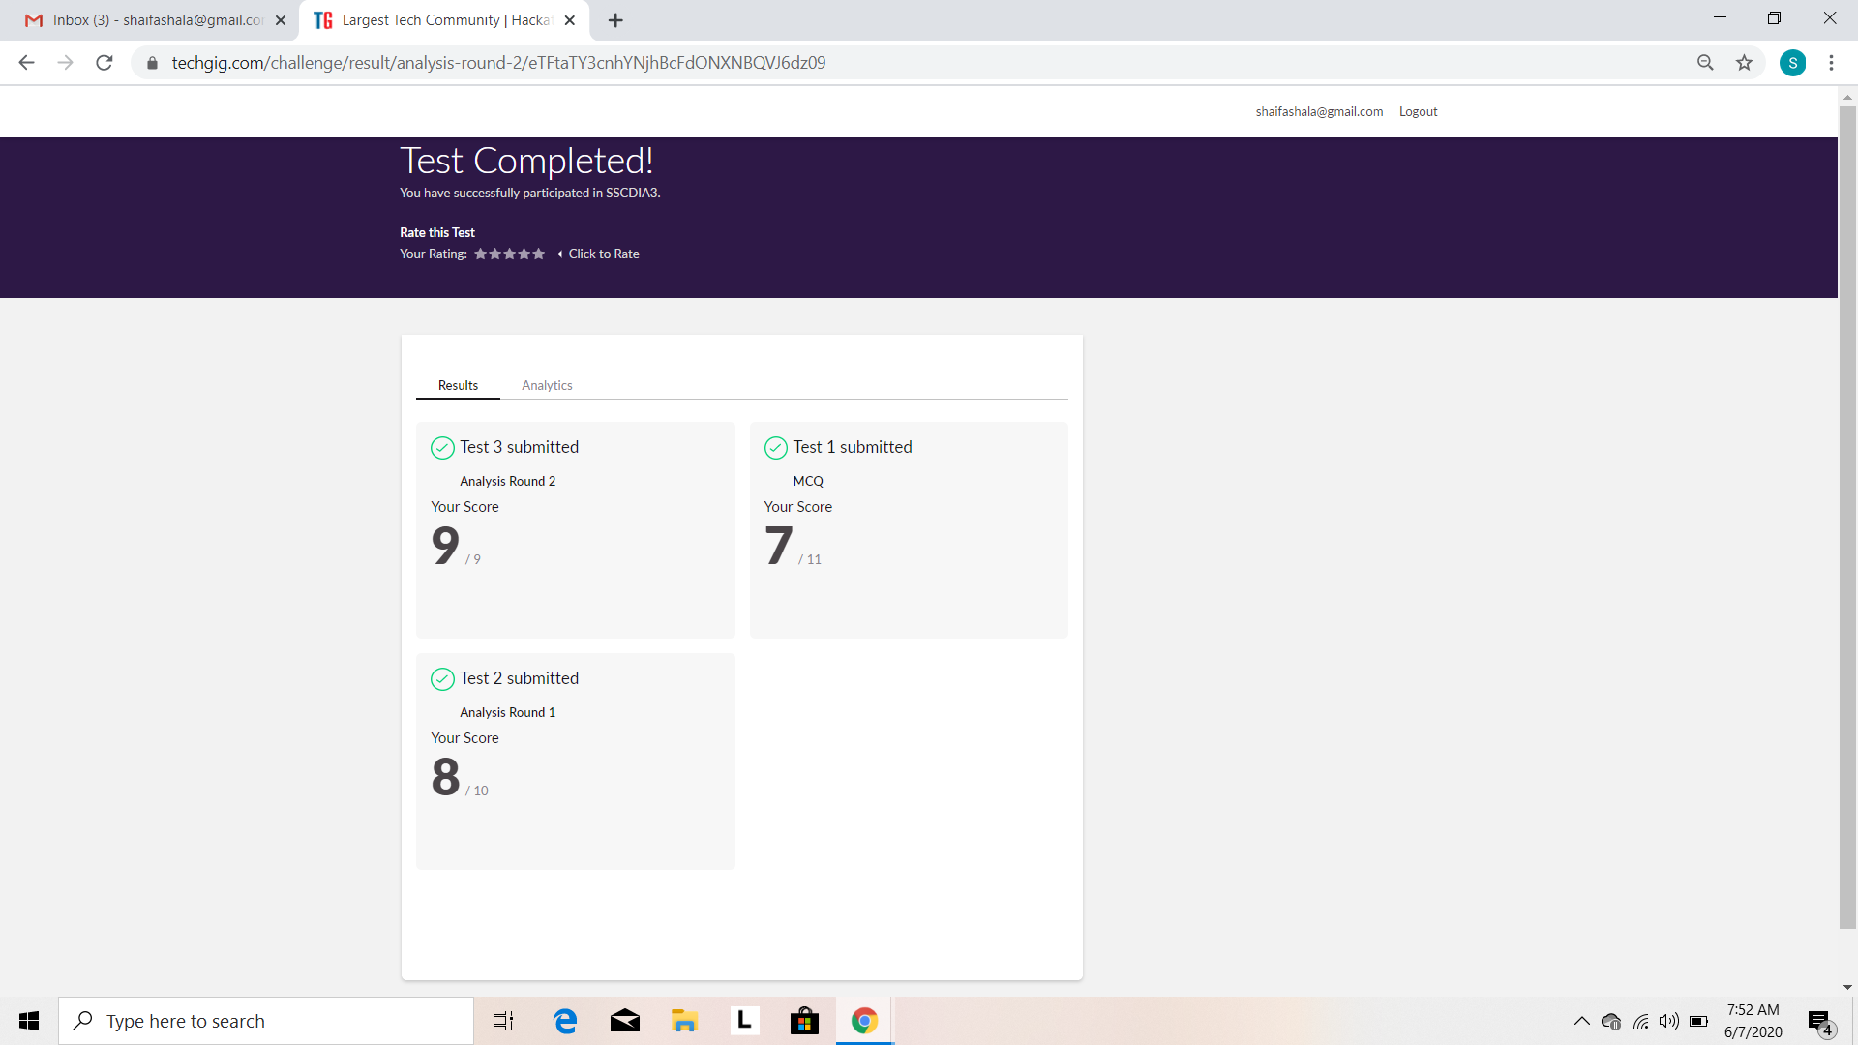

Certification Course Details: (Attach the snapshot and briefly write the report for the same)

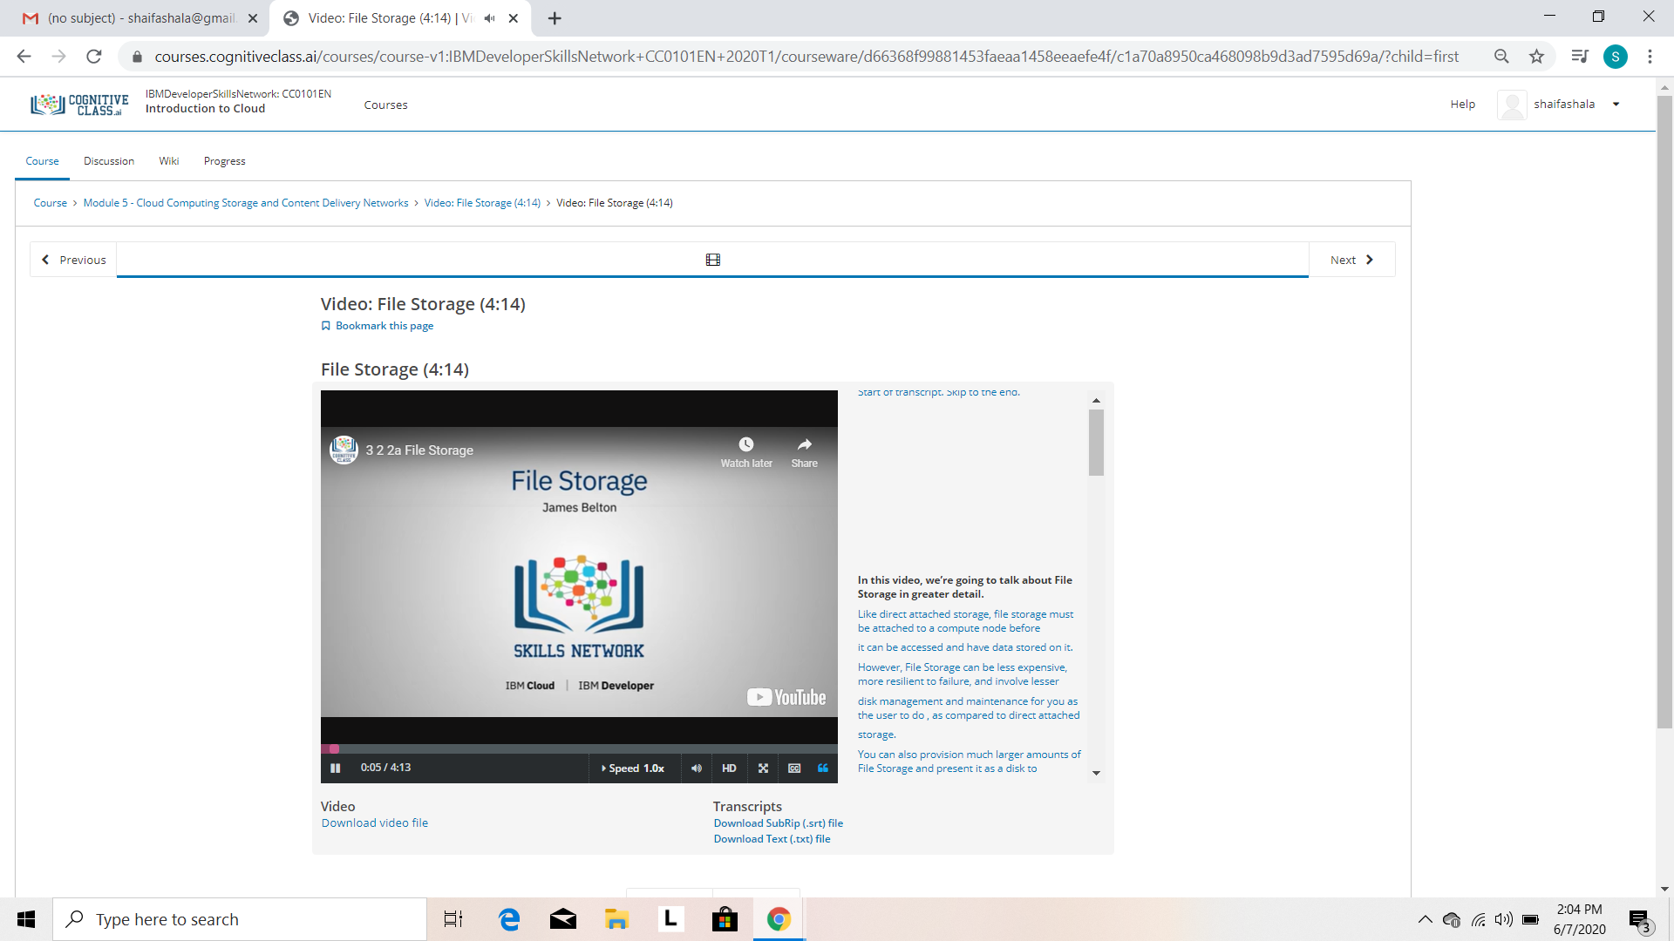

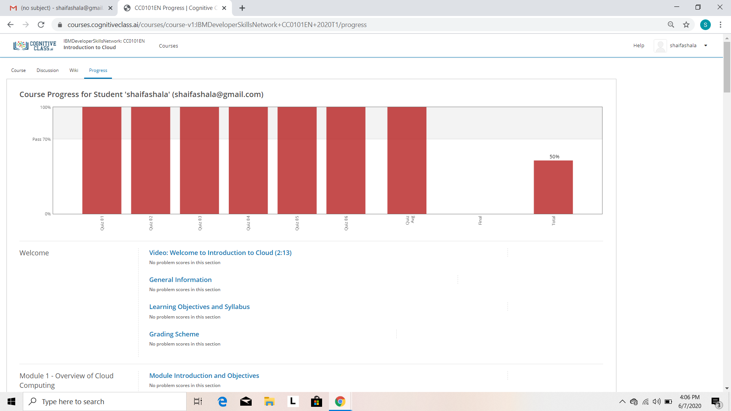

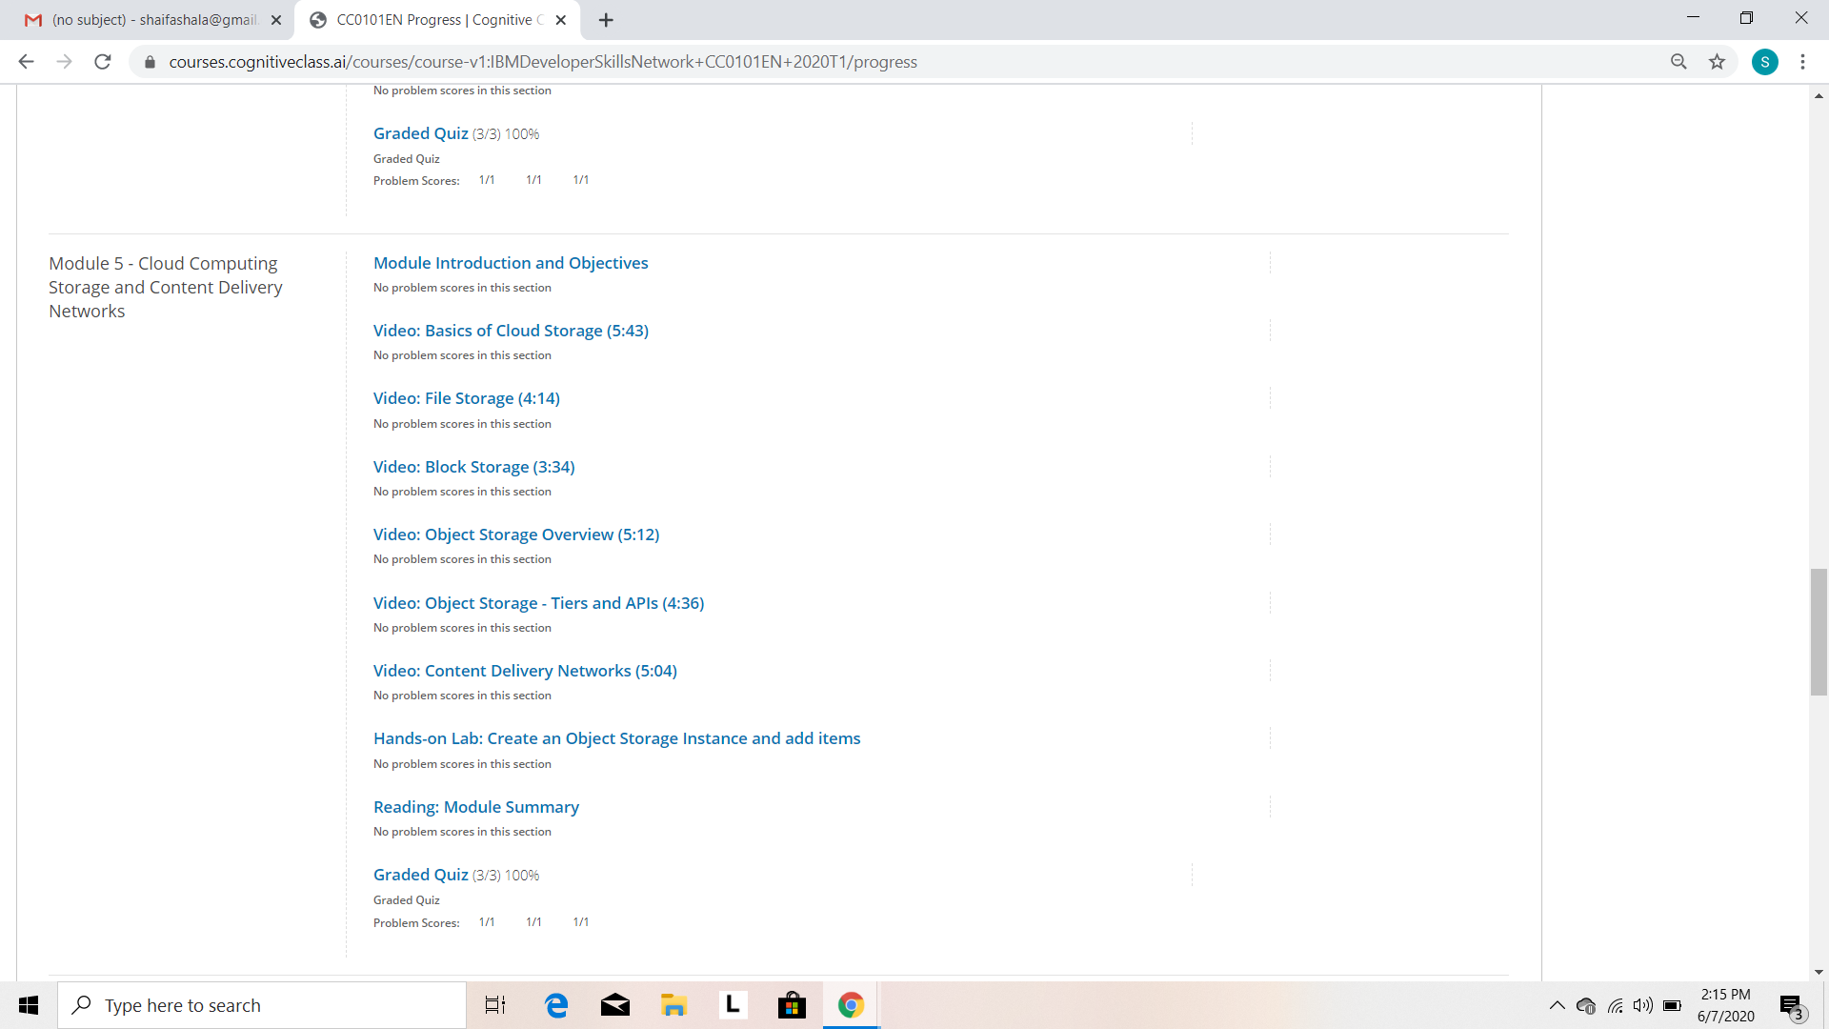

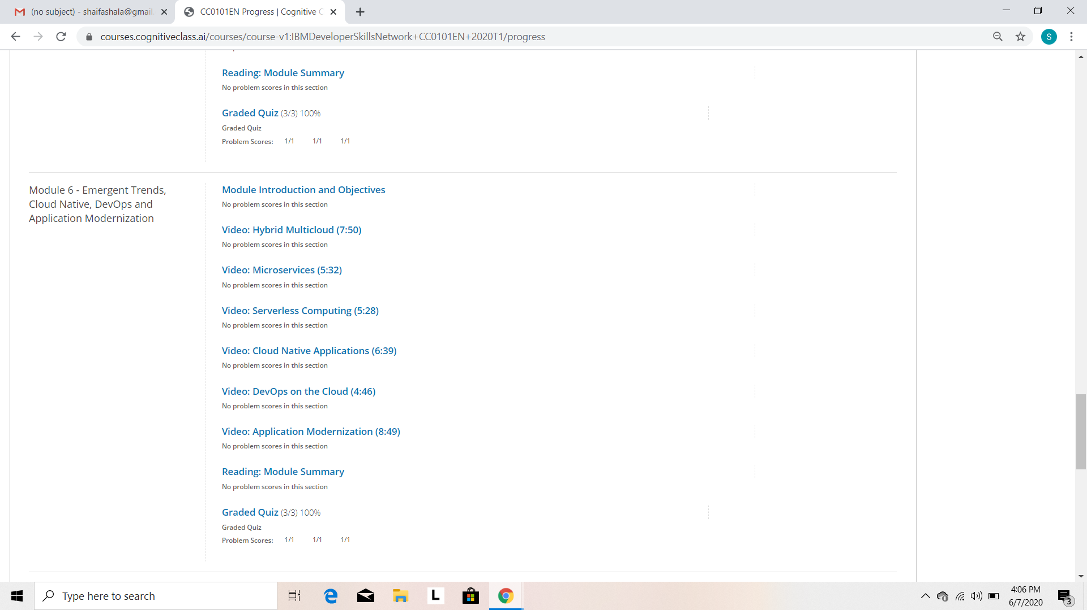

Coding Challenges Details: (Attach the snapshot and briefly write the report for the same)

Program1:

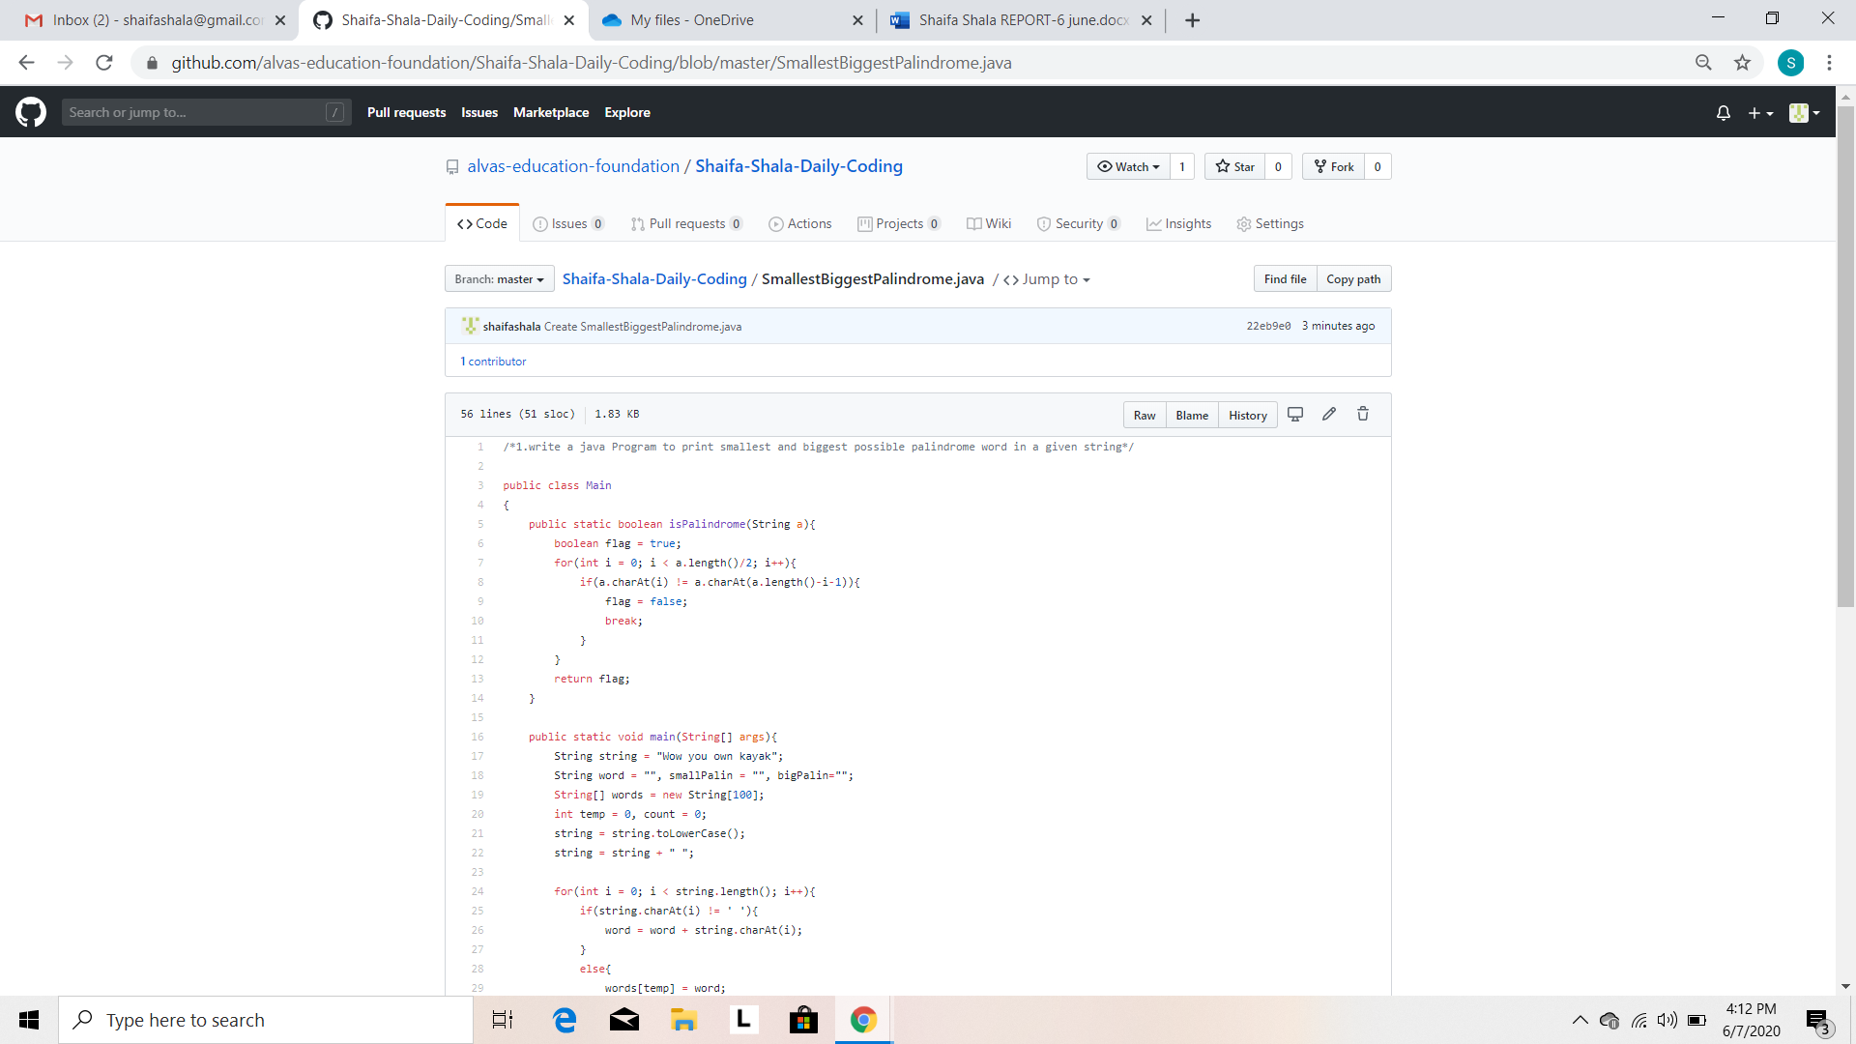

Program2:

